**ONLINE SUPERMARKET**

**Create a simple cloud software application for online super market using any Cloud Service Provider to demonstrate SaaS with the template of customer name, address, phone, email, items, quantity etc. with the item classification form**

**AIM:**

Create a simple cloud software application for Property Buying & Rental process (In Chennai city) using any Cloud Service Provider

**PROCEDURE:**

**STEP 1:**

Open browser and get into zoho creator. Then sign in and click “Create application”. Below given screenshot will appear, hear type the application name of your Aim.

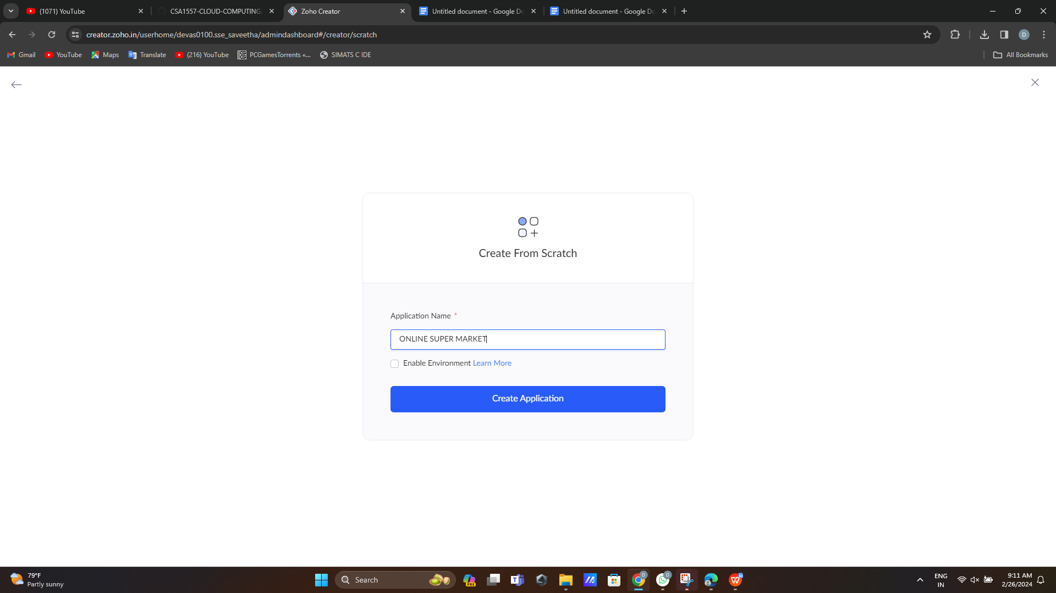

**STEP 2:**

Then select “start from scratch” option and select the proper component from the 4 components listed. For my application I just selected “forms” for the login credentials.

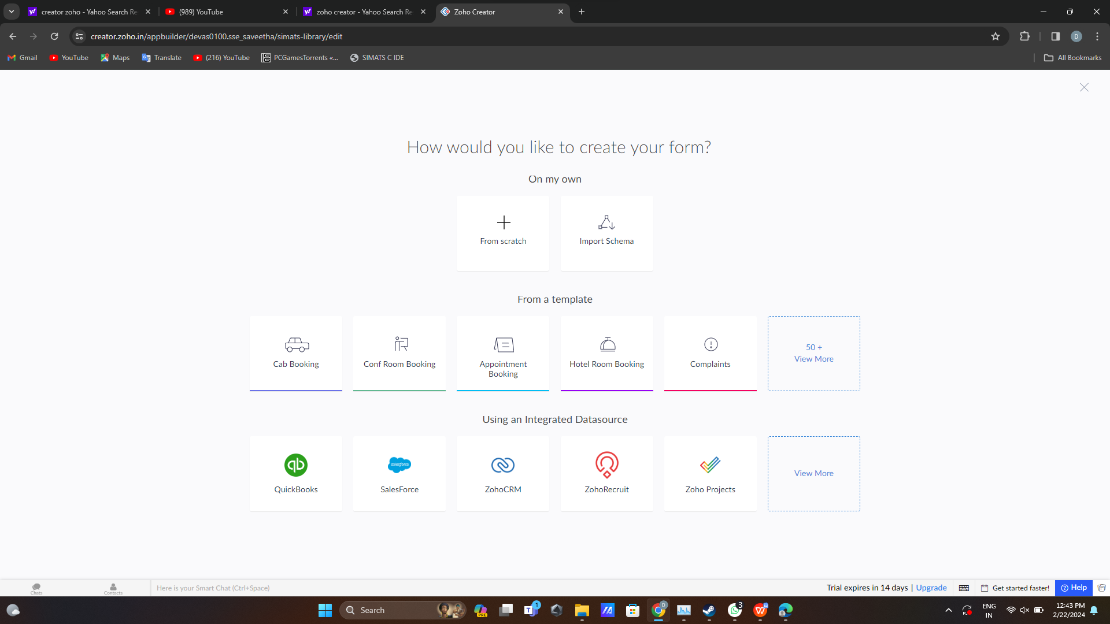

**STEP 4:**

Then provide an appropriate name for our application in the name form which shown below. I gave “AddCart” for my “Online supermarket”

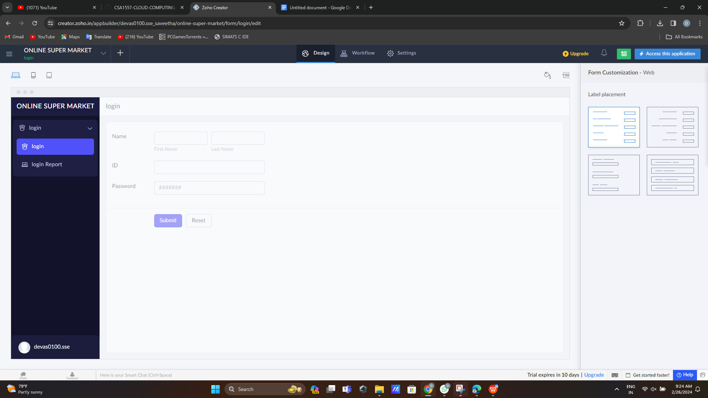

**Step 5: create item search form**

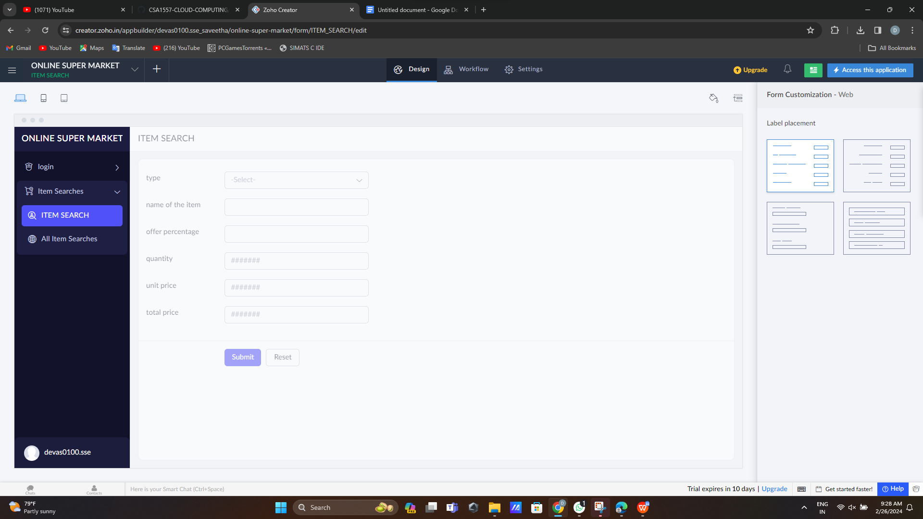

**Step 6:create customer details form**

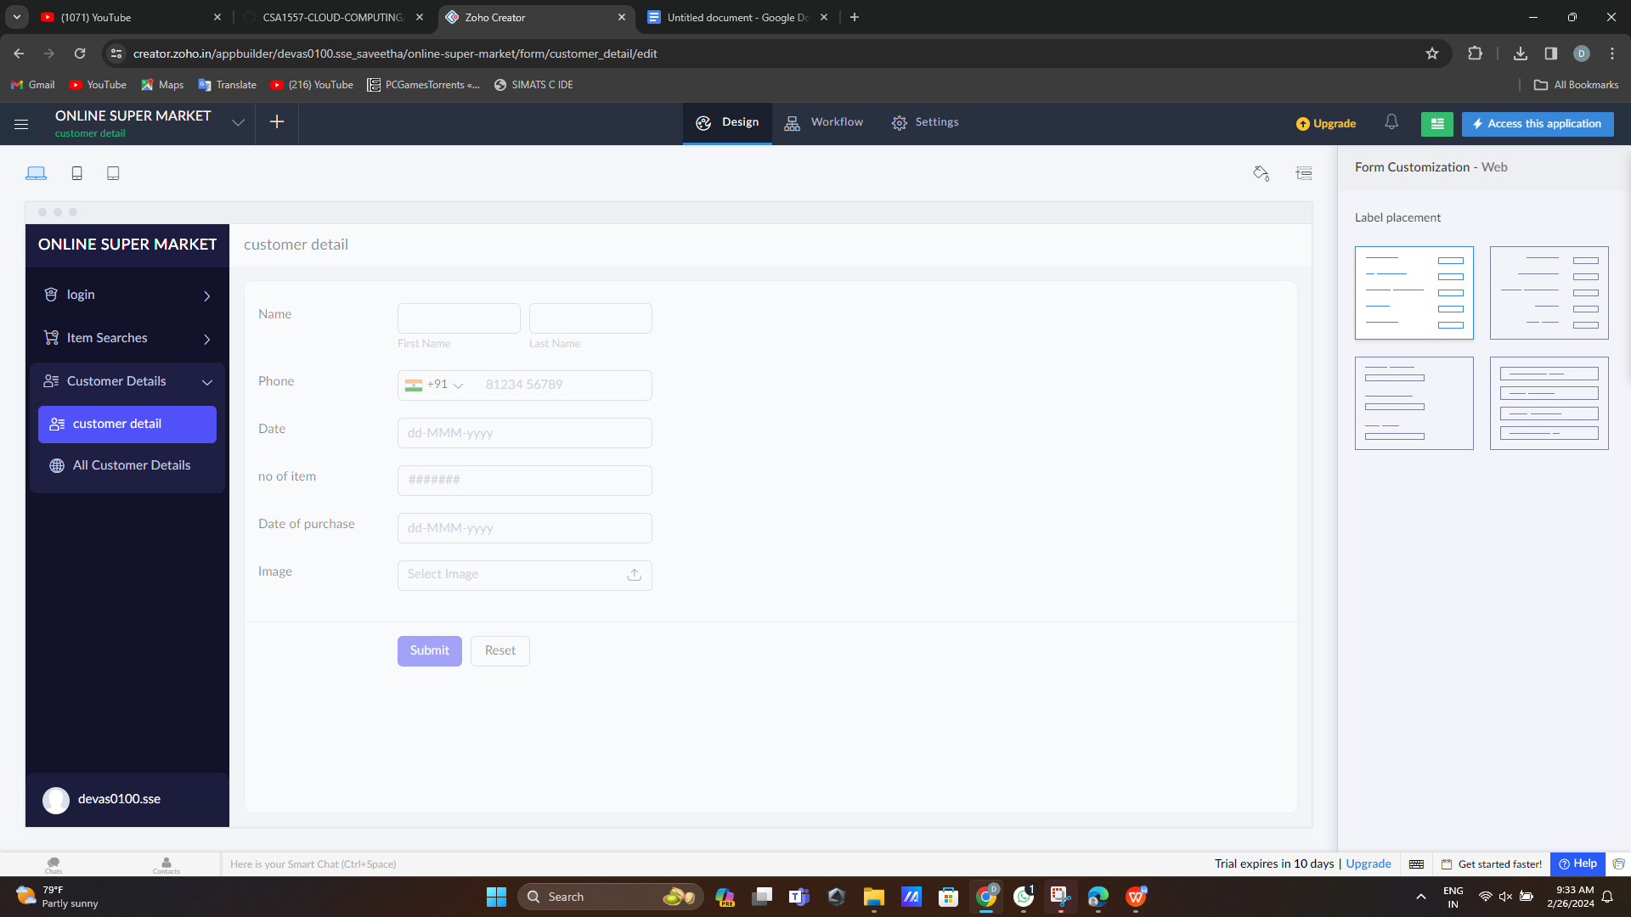

**Step 7:create sign out form[1]**

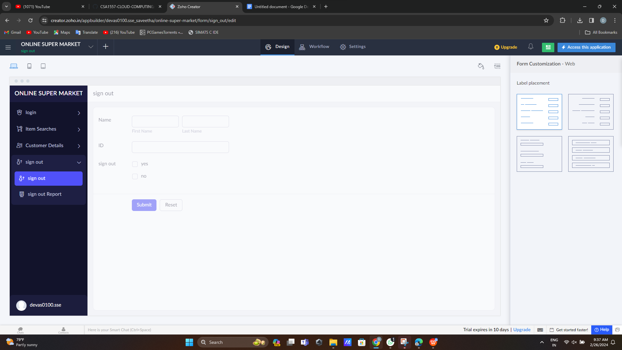

1.